**Write up for The Library**

The challenge description states that “Send a 'hello' to "The Librarian" from the bot list on the Discord server, and he shall guide you further.”   
  
There are a few images attached for troubleshooting, which are not associated with the challenge directly.  
  
On messaging The Librarian, we are started of with -

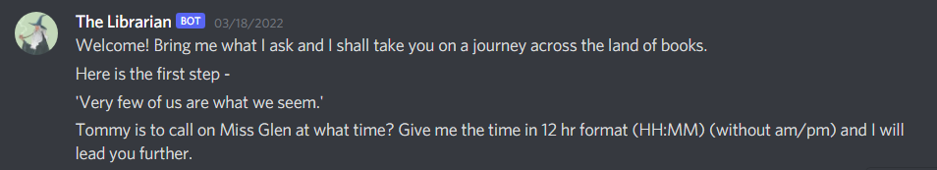

The first line indicates that we need to look out for books.

On Googling the quote 'Very few of us are what we seem.’, we get the name of the book and the author, “The Man in the Mist” by Agatha Christie.

Exploring the [wiki](https://agathachristie.fandom.com/wiki/The_Man_in_the_Mist) pages of the book gives us the required information.



Searching directly for “Tommy is to call on Miss Glen at what time?” also leads us to the Partners in Crime short story collection, where the [Wikipedia page](https://en.wikipedia.org/wiki/Partners_in_Crime_(short_story_collection)#The_Man_in_the_Mist) contains the time directly.

Entering this in the specified format takes us to the next step -



We have the name of the book in the statement itself. So searching for The Son of Neptune seer leads us to Phineas (multiple sources for this - [the Wikipedia page](https://en.wikipedia.org/wiki/The_Son_of_Neptune), [the Wiki page](https://riordan.fandom.com/wiki/The_Son_of_Neptune), summaries).

From the next sentence we look around for Phineus in mythology - searching for Phineus seer mythology leads us to multiple pages ([Wikipedia](https://en.wikipedia.org/wiki/Phineus), [greekmythology](https://www.greekmythology.com/Myths/Mortals/Phineus/phineus.html) sites) which contain the required information - The Golden Fleece (Golden Fleece is an accepted submission as well, no case sensitivity)



Moving on to the next part, we have -



Searching for 'The year without a summer, a vacation, and a classic was created.', gives us the year as 1816, and several articles pointing towards the intended book “Frankenstein” (some articles for your reference - [1](https://www.mentalfloss.com/article/73585/15-facts-about-year-without-summer), [2](https://www.panmacmillan.com/blogs/history/frankenstein-and-the-year-without-a-summer), [3](https://www.npr.org/2007/08/13/12688403/did-climate-inspire-the-birth-of-a-monster), [4](https://blog.ed.ted.com/2017/11/07/an-animators-take-on-mary-shelleys-frankenstein/)).

The next line is confirmed from the [Wikipedia article](https://en.wikipedia.org/wiki/Frankenstein) for the book -



From this we need to enter the university of the creator, which is University of Ingolstadt.

For the next part we have -

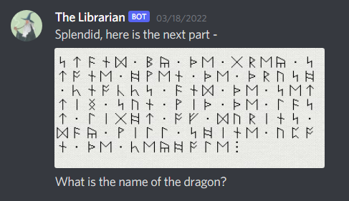

Using Google Lens to dig around a bit, we understand that the given runes are Anglo Saxon.

Translating them, we get

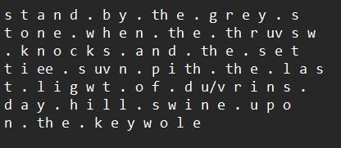

Searching for this quote gives us the name of the book for this step “The Hobbit”.

From this the name of the dragon is a Google search away - “Smaug”.

For the final part of the challenge, we have -

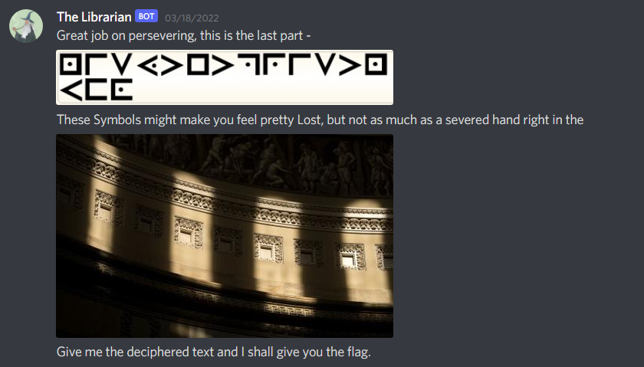

For this step, there was a direct reference to the book name with the capitalized letters, but not the only one, just to make life a bit easier.

If this was missed, the line “These Symbols might make you feel pretty Lost, but not as much as a severed hand right in the ‘place in the image’ served as the book reference.  
  
Reverse Googling the image reveals that it is of the US Capitol. So searching for the phrase gives us the name of the book “The Lost Symbol” by Dan Brown.

The last step involves cryptography, however the cipher used is completely from the book, so simply Googling for The Lost Symbol cipher gives us the method which was used in the book. The steps which are required are pigpen followed by Duhrer’s magic square. Some sources for this are - [1](https://sites.google.com/site/lostsymbolproject/masonic-cipher), [2](https://www.mysteriology.com/blog/a-sketchbook-that-feels-like-time-travel/), [3](https://youtu.be/6fedjvyRt5w).

The step where most people were stuck was due to just going with Pigpen, which was pretty easy to identify, being a common cipher. However, this step was in accordance with the theme of the question, hence the implementation of all the steps was needed to get the right answer.

Decrypting the pigpen gives us ‘nisytetprisnufo’, followed by the Duhrer square, which gives us ‘osintisprettyfun’.

Entering this gives us the flag -



Flag : vishwaCTF{b00ks_d0_b3_1nt3r3st1ng!}